**Project Title : Scarcity_items ,Overstocked Items and Disputes analysis**

**Problem Statement:**Monitor and analyze trends in demand, supply, customer conversion, and experience metrics of items categorized as scarce or potentially scarce using Sql.

**Dataset Overview:**

1. **Item_ID:** A unique identifier for each item (e.g., ITEM00000, ITEM00001).
2. **Category:** The product category (e.g., "Home Appliances," "Toys," "Groceries," "Apparel," "Electronics").
3. **Region:** The geographical region where the item is stocked or sold (e.g., "South," "West," "Central," "East," "North").
4. **Date:** The date of the recorded transaction or inventory update (e.g., 7/27/2023, 1/1/2023).
5. **Stock_Level:** The current inventory level (quantity available in stock).
6. **Demand:** The number of units requested or expected to be sold.
7. **Supply:** The number of units available or supplied.
8. **Is_Scarce:** A binary indicator (Yes/No) showing whether the item is currently in short supply.
9. **Potentially_Scarce:** A binary indicator (Yes/No) flagging items that may become scarce in the future.
10. **Conversion_Rate:** How much Demand fullfilled by seller by available stocks
11. **Experience_Score:** A numerical score (possibly customer satisfaction or employee performance rating).
12. **Dispute_Amount:** A value related to disputes (e.g., refunds, claims).
13. **Win_Amount:** The amount recovered or won in a dispute.
14. **Recouped_Amount:** The amount successfully recouped (e.g., from losses or disputes).
15. **Tag_Status:** The status of the item (e.g., "Reviewed," "Flagged," "Resolved," "Escalated").
16. **Net_Loss:** The net financial loss by seller
17. **Spike_Indicator:** It is a binary flag (Yes/No) that identifies sudden, abnormal changes in demand, supply, or sales activity for a specific item.

**FORMULAS:**1) For Calculating **Conversion_Rate** =(Stock_level+Supply)/Demand

**Conversion rate means**= Units you can fullfill / Total units Demanded

**Stock_Level** = Units on hand

**Supply** = Incoming units

**Demand** = Requested units

**2)** For Calculating **Net_Loss =** (Dispute_ Amount-( Win_Amount + Recouped_Amount ))

**Analyzing Scarce_items_analysis dataset using sql**

**1)Renaming Table Name**

**Query:**

Rename table scarce_items_analysis_edited to item_analysis;



**2) Displaying all values**

**Query:**

Select * from item_analysis;

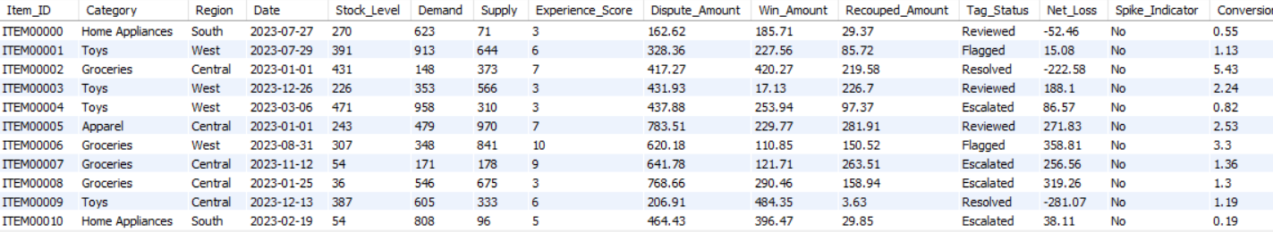

**3) Identifying Current Scarce Items (**mentioned as **shortage_Gap)**

**Query:**

SELECT Item_ID,Category,Region,Date,

Stock_Level,Demand,

(Demand- (Stock_level+supply)) AS Shortage_Gap,

Conversion_Rate, Experience_Score,

Net_Loss,Spike_Indicator FROM item_analysis WHERE Is_Scarce = 'Yes'

ORDER BY Shortage_Gap DESC;

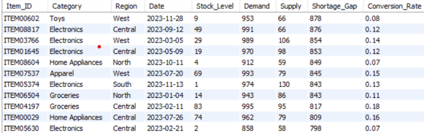

**Explanation:**

Here the demand which wasn’t fulfilled by the seller is mentioned as the **Shortage_Gap** ,Higher the **Shortage_Gap** lower the conversion Rate.

**4) Items with Poor Conversion Rate**

**Query:**

SELECT Category, Region, Conversion_Rate,

Experience_Score,

Demand, (Supply+Stock_level) as Total_stocks

FROM item_analysis WHERE (Is_Scarce = 'Yes')

AND Conversion_Rate < 1 ORDER BY Conversion_Rate;

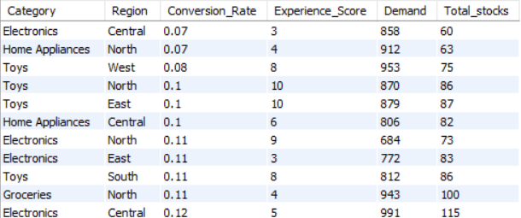

**Explanation:**

This shows very poor conversion rate due to more Scarcity

**5) Detect understocked and Overstocked items**

**Query:**

SELECT Item_ID, Category

CASE

WHEN (stock_level+Supply) < Demand THEN 'Understocked'

WHEN (stock_level+Supply )> Demand * 1.5 THEN 'Overstocked'

ELSE 'Balanced'

END AS Inventory_Status

FROM item_analysis;

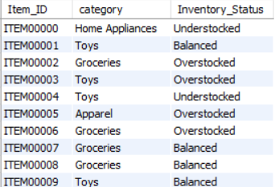

**Explanation:**

This shows the Inventory status based on demand from customer.

**6) Net Loss Analysis for each Category**

**Query:**

SELECT

Category,

Round( SUM(Net_Loss),2) AS Total_Net_Loss,

Round( AVG(Net_Loss),2) AS Avg_Net_Loss,

COUNT(item_id) AS Item_Count

FROM item_analysis

WHERE net_loss>0

GROUP BY Category

ORDER BY Total_Net_Loss DESC;

**Explanation:**

This shows the loss for seller in each category due to compliance in products, quality issues ,So the amount is refunded to customer .This will be the loss for seller which is calculated as **Total_Net_Loss**,**Avg_Net_Loss**.

**7)Finding Spike occurring on particular category based on demand**

SELECT

Item_ID,

Date,

Demand,

Supply,

Stock_Level,

(Demand - (Supply+stock_level)) AS Demand_Supply_Gap,

spike_indicator

FROM item_analysis

WHERE Spike_Indicator = 'Yes'

AND Category = 'Electronics'

ORDER BY Demand_Supply_Gap DESC;

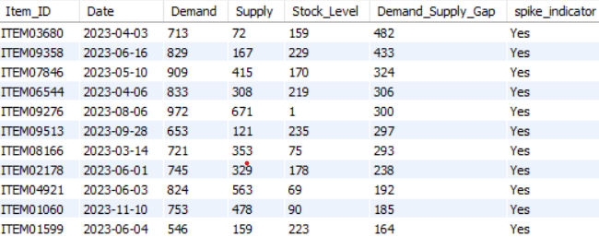

**Explanation:**

This **Demand_supply_gap** tells the remaining current demand which was not fullfilled by our available products in inventory**.**

**8)** **Spikes in 2023 ( Like Holiday Season )**

SELECT

Category,

COUNT(*) AS Total_Items,

COUNT(CASE WHEN Spike_Indicator = 'Yes' THEN 1 END) AS Spike_Items

FROM item_analysis

WHERE Date BETWEEN '2023-11-01' AND '2023-12-31'

GROUP BY Category

ORDER BY Spike_Items DESC;

**Explanation:**

Here **Spike_Items** means highly demanded products ,So In these months there will be holiday vacations for students ,so the **need of Groceries and Apparel(Clothing)** ,**Toys** **etc** demand is increasing

**9) Monthly demand trends**

**Query:**

SELECT

EXTRACT(MONTH FROM Date) AS Month,

Round( AVG(Demand),2) AS Avg_Demand

FROM item_analysis

GROUP BY Month

ORDER BY Month;

**Explanation:**  
This Shows the Monthly Avg_Demand for each category products which includes **Groceries, Electronics, Home Appliances** etc

**10)Filter Scarce Items with Spikes**

**Query:**

SELECT Item_ID, Category, Demand

FROM item_analysis

WHERE Is_Scarce = 'Yes' AND Spike_Indicator = 'Yes';

**Explanation:**This Shows sudden high demand for products which is indicated by spike_indicator and Is_Scarcity

**11) Finding Is_Scarce_Percentage**

**Query:**

Select Concat( Round (COUNT(

CASE WHEN Is_Scarce = 'Yes' THEN 1 END) * 100.0 / COUNT(Item_id),2),'%')

AS Scarcity_Rate_Pct

FROM item_analysis;

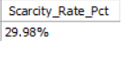

**12) Finding Potential_Scarce Items**

**Query:**

Select item_id,category ,demand as Current_demand,(supply+stock_level) AS Current_Stocks_Avail from item_analysis where potentially_scarce='Yes' ;

**Explanation:**

Eventhough the Current_Stocks can fullfill the Current_Demand now , afterwards there will be only few Current_Stocks will be available .So we need to refill the Current_Stocks as soon as possible based on **Potentially_Scarce** because anytime we get the next huge demand .

**13) Finding no of items based on Tag_Status**

**Query:**

Select Tag_Status,count(*)as No_of_items from item_analysis

where Tag_Status in ('Flagged', 'Escalated', 'Reviewed', 'Resolved')

group by Tag_Status;

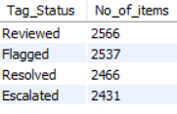

**Explanation:**

Counting no of Items based on their Tag_Status

**14) Find** **User Experience Rating Percentage**

**Query:**

SELECT Concat(Round(count(case when experience_score in (1,2,3,4

) then 1 End )* 100 / Count(experience_score),2),'%') as Low_Rating_Percentage,

Concat(Round(count(case when experience_score in (5,6,7

) then 1 End )* 100 / Count(experience_score),2),'%') as Avg_Rating_Percentage,

Concat(Round(count(case when experience_score in (8,9,10

) then 1 End )* 100 / Count(experience_score),2),'%') as High_Rating_Percentage from item_analysis



**Explanation:**

This displays the rating percentage based on Experience_score from(1 to 10).

1 to 4 = Low Rating  
5 to 7 = Average Rating  
8 to 10 = High Rating

**Areas to be Improved:**

* Need to reduce the **Scarcity_rate** and to store additional stocks in our inventory and make dealer ready, to refill the products as soon as stock_level is reduced in any category ,to improve **Conversion_Rate**.
* Need Improvement in **Buying good quality Products** From Good Dealer and Good Manufacturer to reduce **Net_Loss** on Each Category**.** Without this we may not able to build trust among Customers.